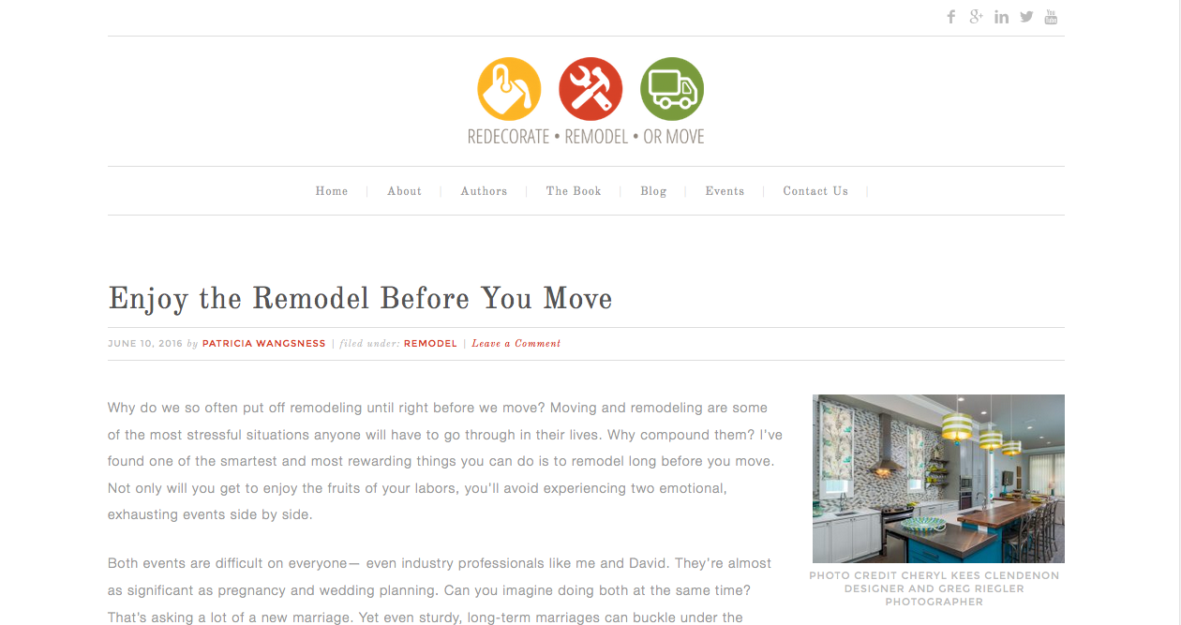

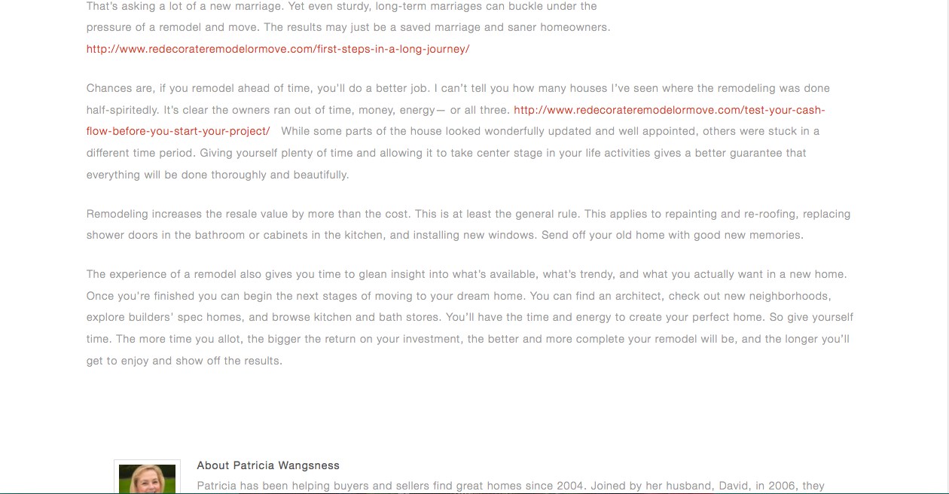

To see the entire web page, a ghost writing project, [click here](http://www.redecorateremodelormove.com/enjoy-the-remodel-before-you-move/).